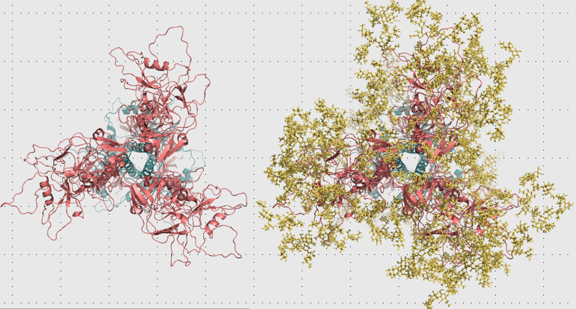

**D**

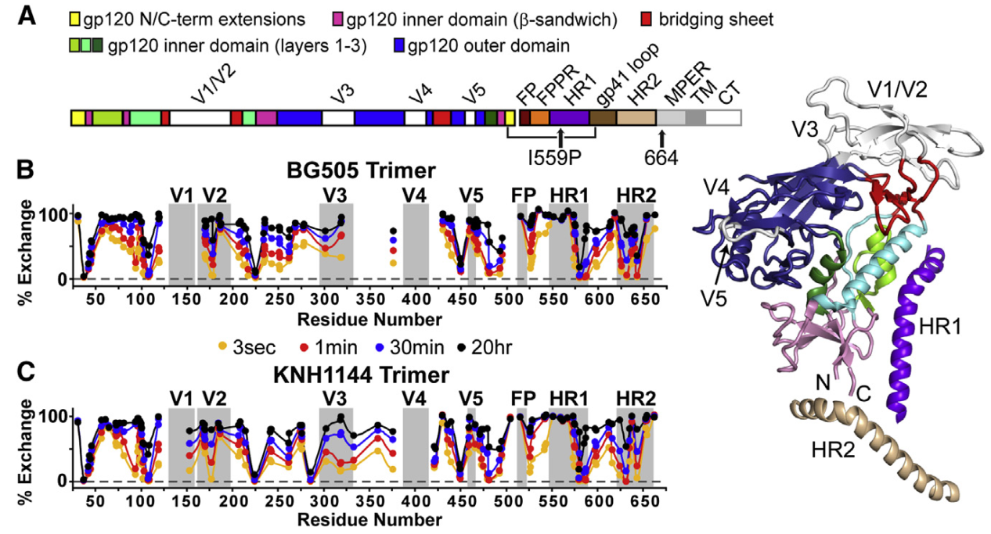

**Figure 1.** Starting point. (A) BG505 SOSIP sequence with mutations introduced to the model. (B) and (C) show HDX-MS data for BG505 and KNH1144 isolates. Most disordered are variable loops (V1-V5), first half of HR1 and very end of HR2. Adapted from Guttman et al (2014). (D) N-linked glycans constitute 40% of Env weight, shown here extent of glycosylation on KNH1144 trimer.

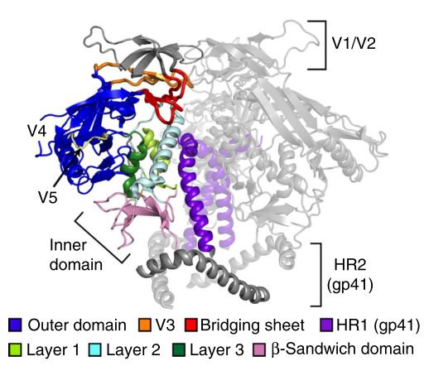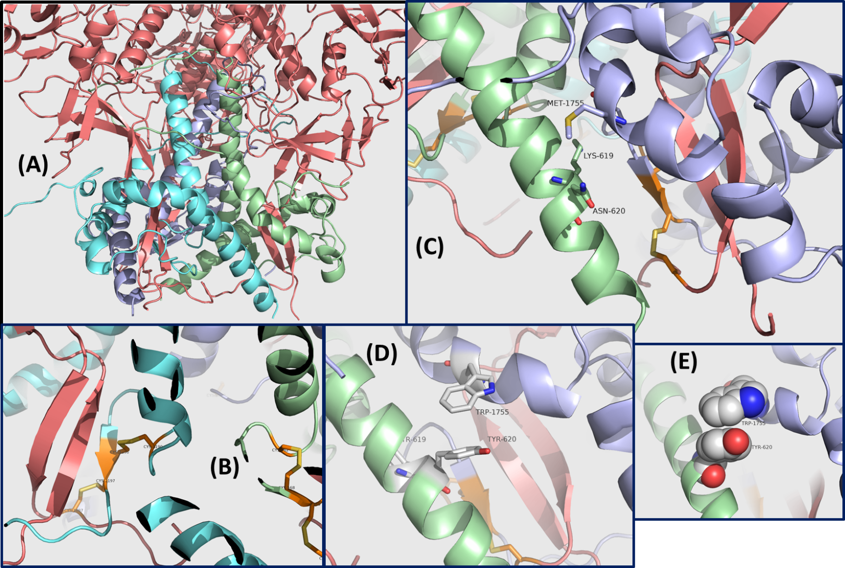

Figure 2. Initial trimer design with Rosetta. (A) gp41 trimer (cold colors) shown in the context of whole Env (salmon). (B) disulphide bonds that were engineered SOS in between gp41 and gp120. (C) The c-terminus of alpha helical HR2 domain (S546 through Y588) interacts with the first helix in gp41 sequence (T530 thourgh R544). RosettaDesign predicted mutation sites to strengthen HR2 – adjacent gp41 N-terminus interaction: N656 from one monomer (light purple) to M535 of HR2 from another monomer (green), and polar K655 which faces hydrophobic core. (D) Triple mutant M535W, N656Y and K655Y had the lowest Rosetta score. (E) Y656 and W535 pi-stacking interaction.

Figure 3. Gp140 (left) and gp140_trunc (right). Gp140 has a pg120 subunit (orange and blue) and gp41 (green). The gp120 portion that penetrates gp41's cavity is shown in blue, together with the linker region.

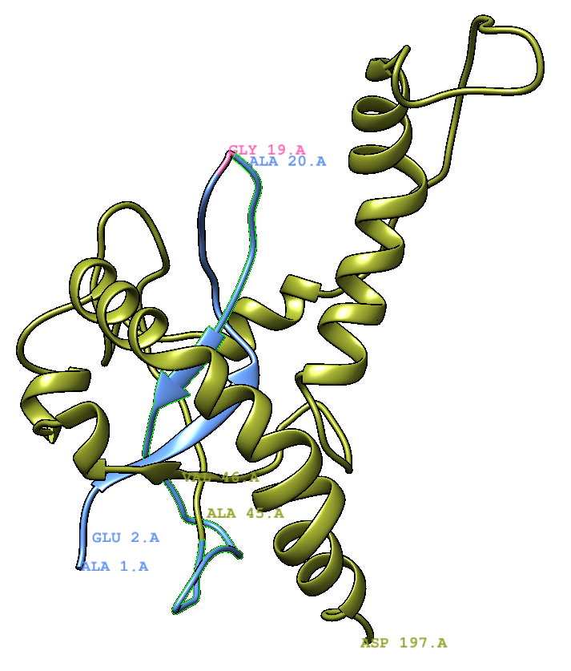

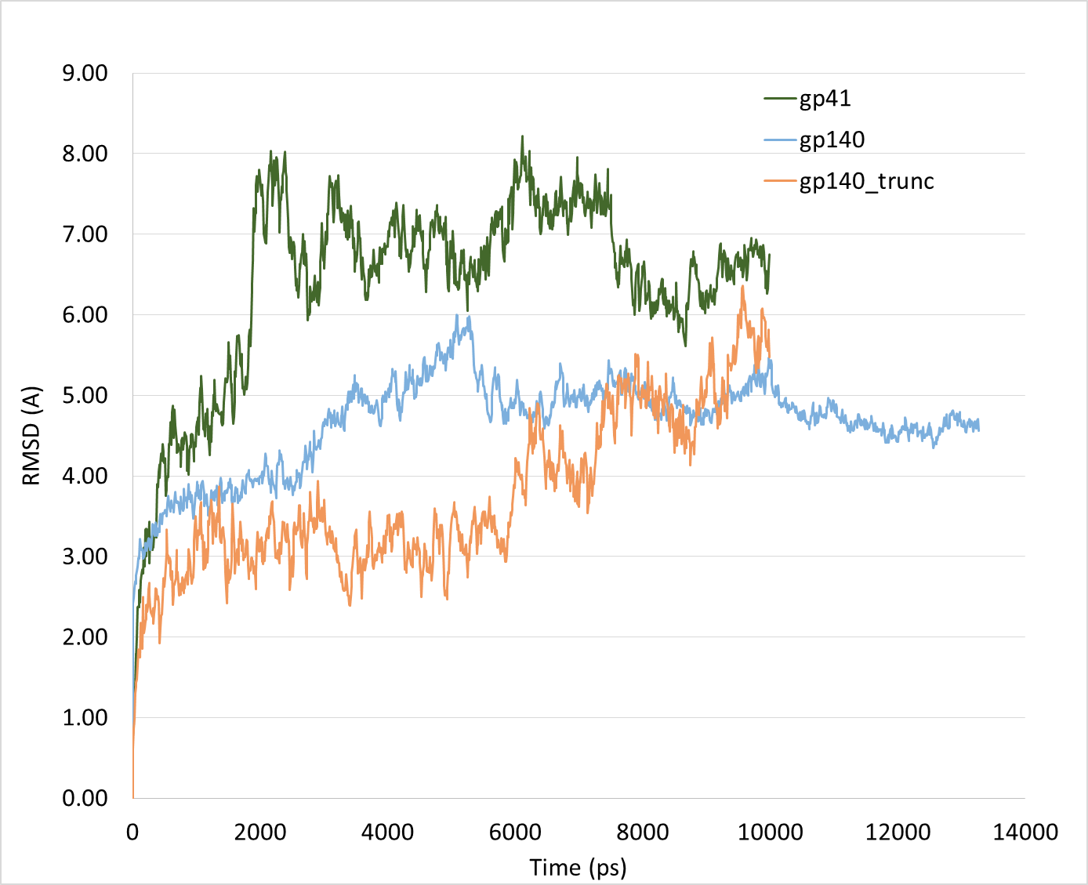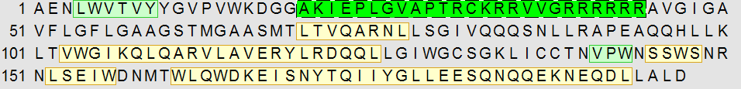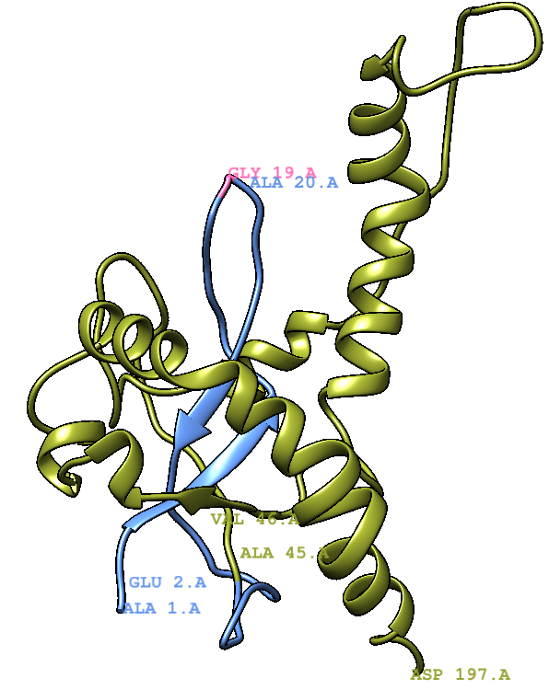

Figure 4. RMSD analysis of three constructs.

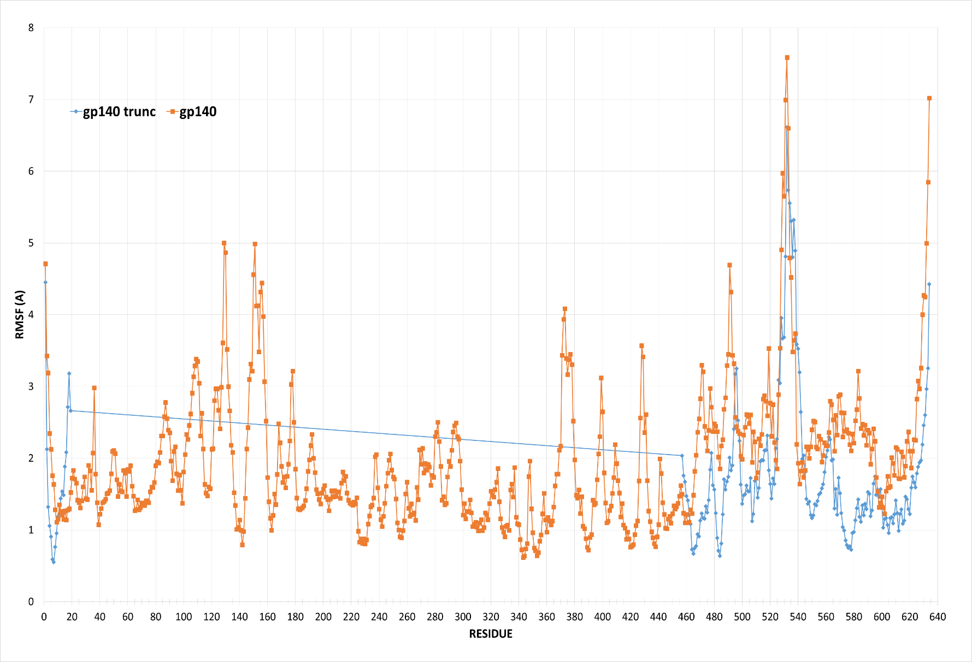

Figure 5. Aligned RMSF values for gp140 and gp140_trunc. Gp140_trunc is the same as gp41, except for a 44 aa sequence shown in green that was inserted, and originally belongs to gp120. The stabilizing insert is shown in blue in the cartoon.

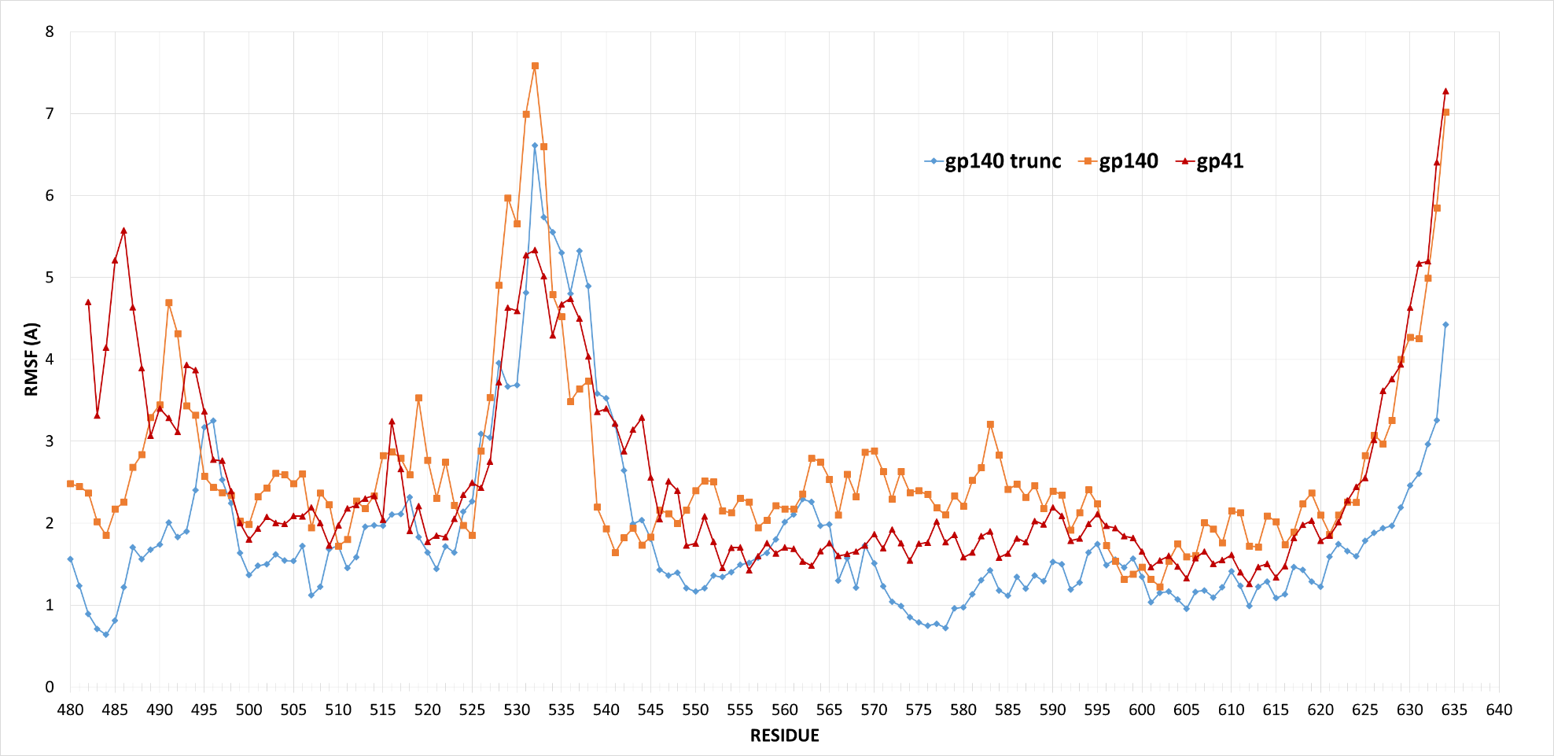

Figure 6. Drastic gp140 truncation leaving only 24 gp120 residues to stabilize gp41 produces the most stable structure. RMSF alignment of the corresponding gp41 sequence for gp140 (full gp120+gp41), full gp41, and truncated gp140. Highly disordered region L526-W541 shown in green.

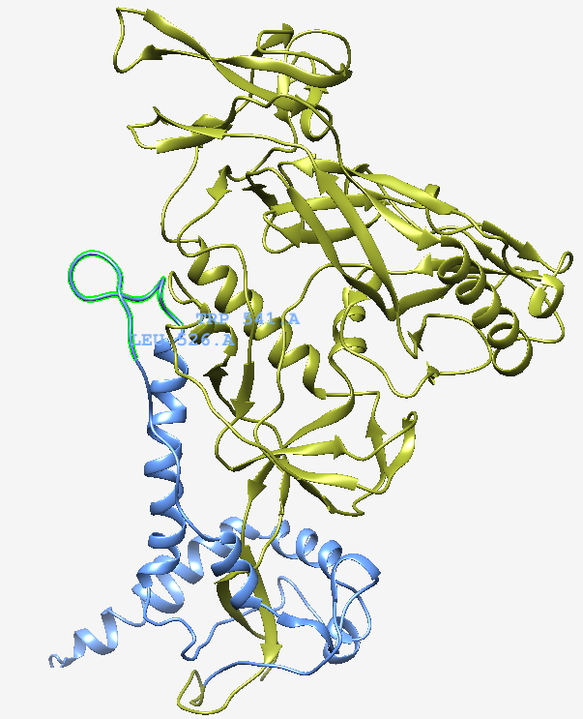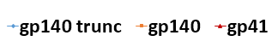

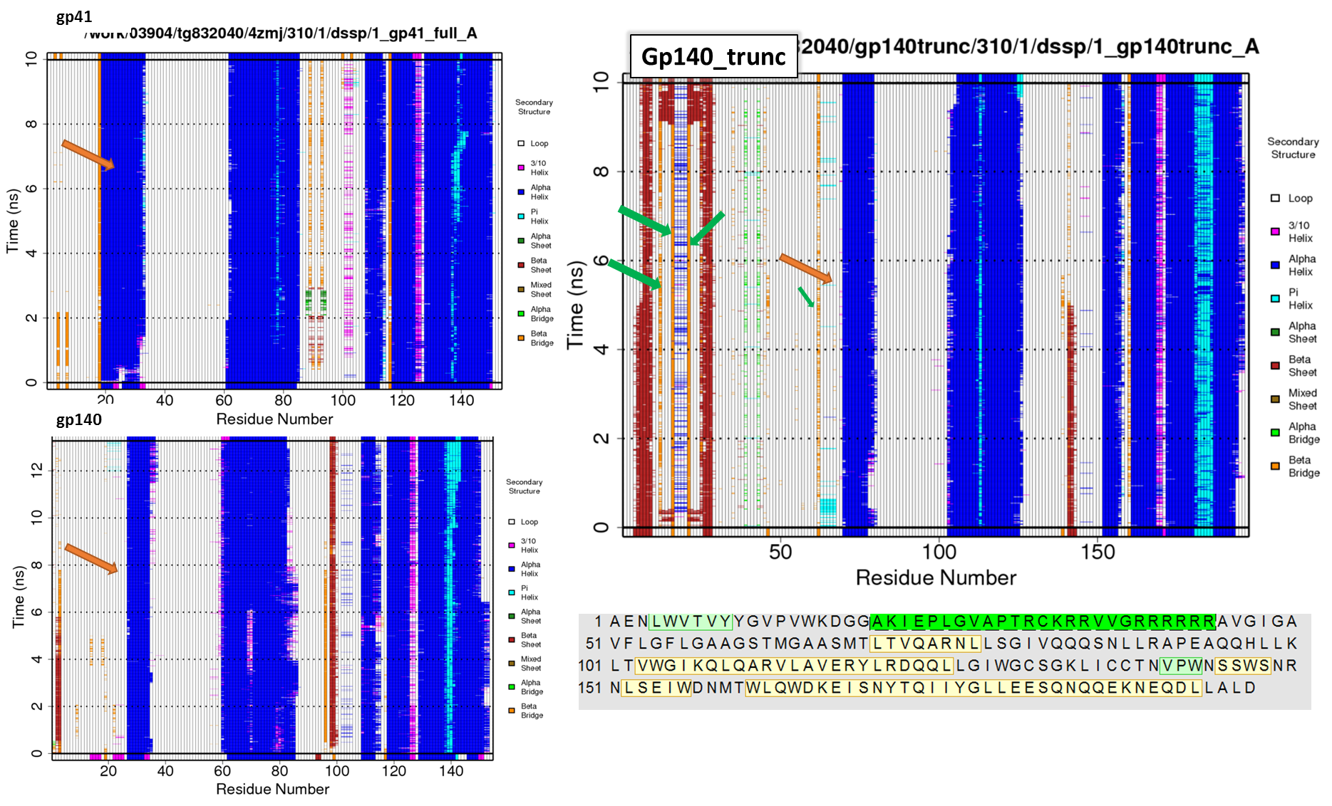

Figure 7. Secondary structure analysis indicates loss of alpha helical structure at 529-536 region of a helix that is adjacent to another protomer's HR1 (orange arrows), and is the site of M535W trimer-stabilizing mutation. Green arrows indicate sites of non-native salt bridge interactions in gp140_trunc.

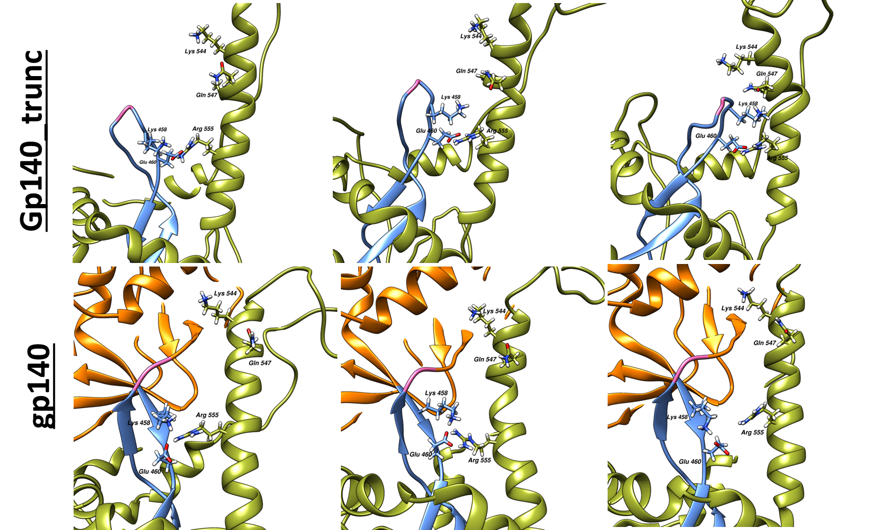

Figure 8. Transient and permanent salt bridges at E460-R555 and K458-Q547 break the HR1 alpha helix (HR1 helix is green). Residues from gp120 insert are blue.

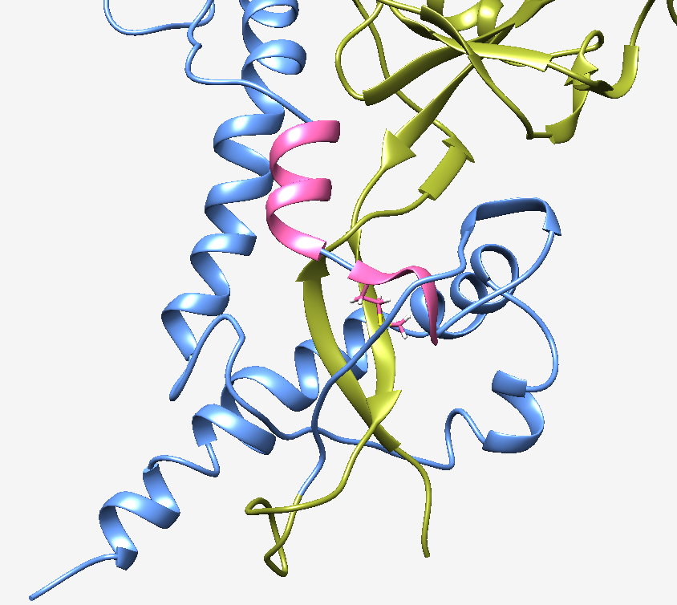

Figure 9. MD simulation proves that AASM(535)TLTVQARNL sequence (pink) does not have a stable helical secondary structure. Contrary to what the Xtal structure 4ZMJ is showing, the single helix breaks into two helices via T536. Therefore stabilizing M535 is of paramount importance. Thr536 is a blue linker, M535 is shown with side chain.

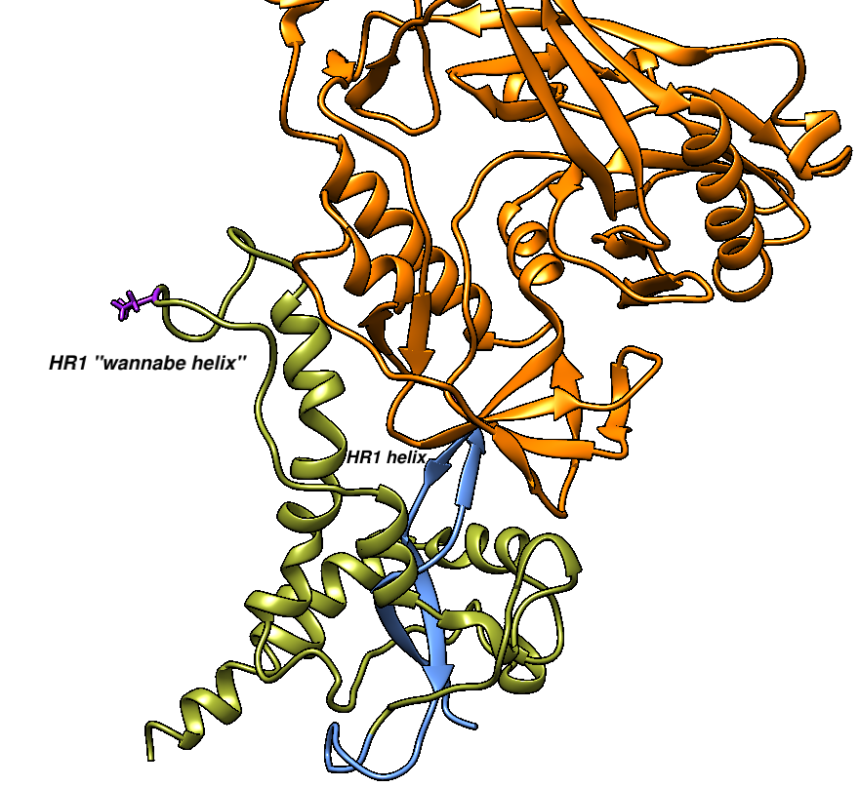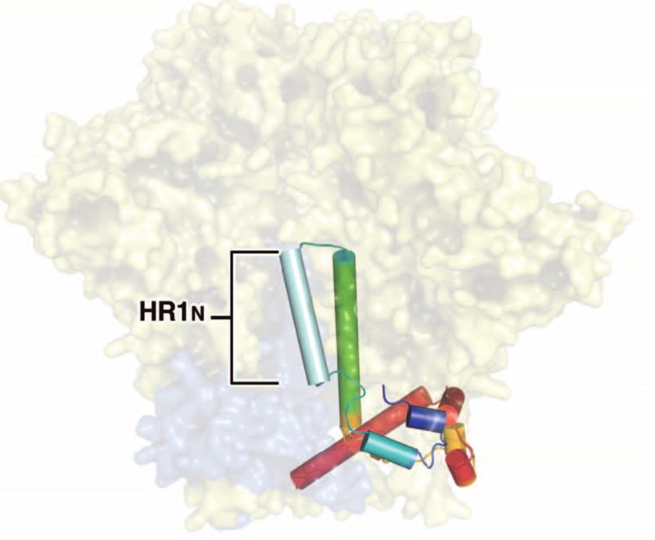

Figure 10. HR1's N-terminus wants to be a helix, but I559P prevents that.

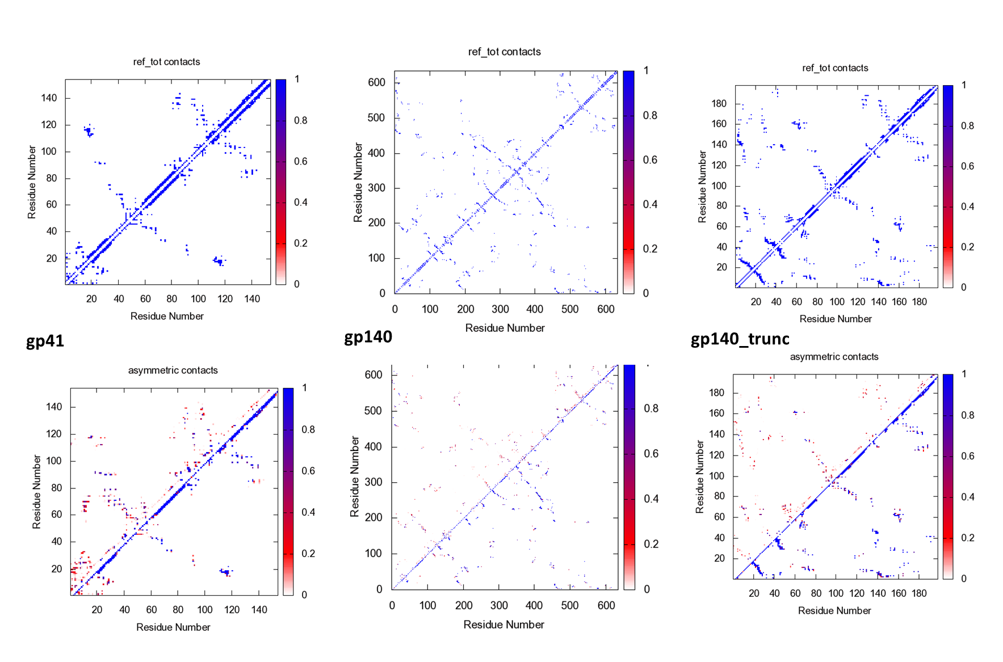

Figure 11. Contact analysis.

Figure 12. RMSF by residue of gp140. Regions with higher than 3 A RMSF are labeled and colored hot pink.

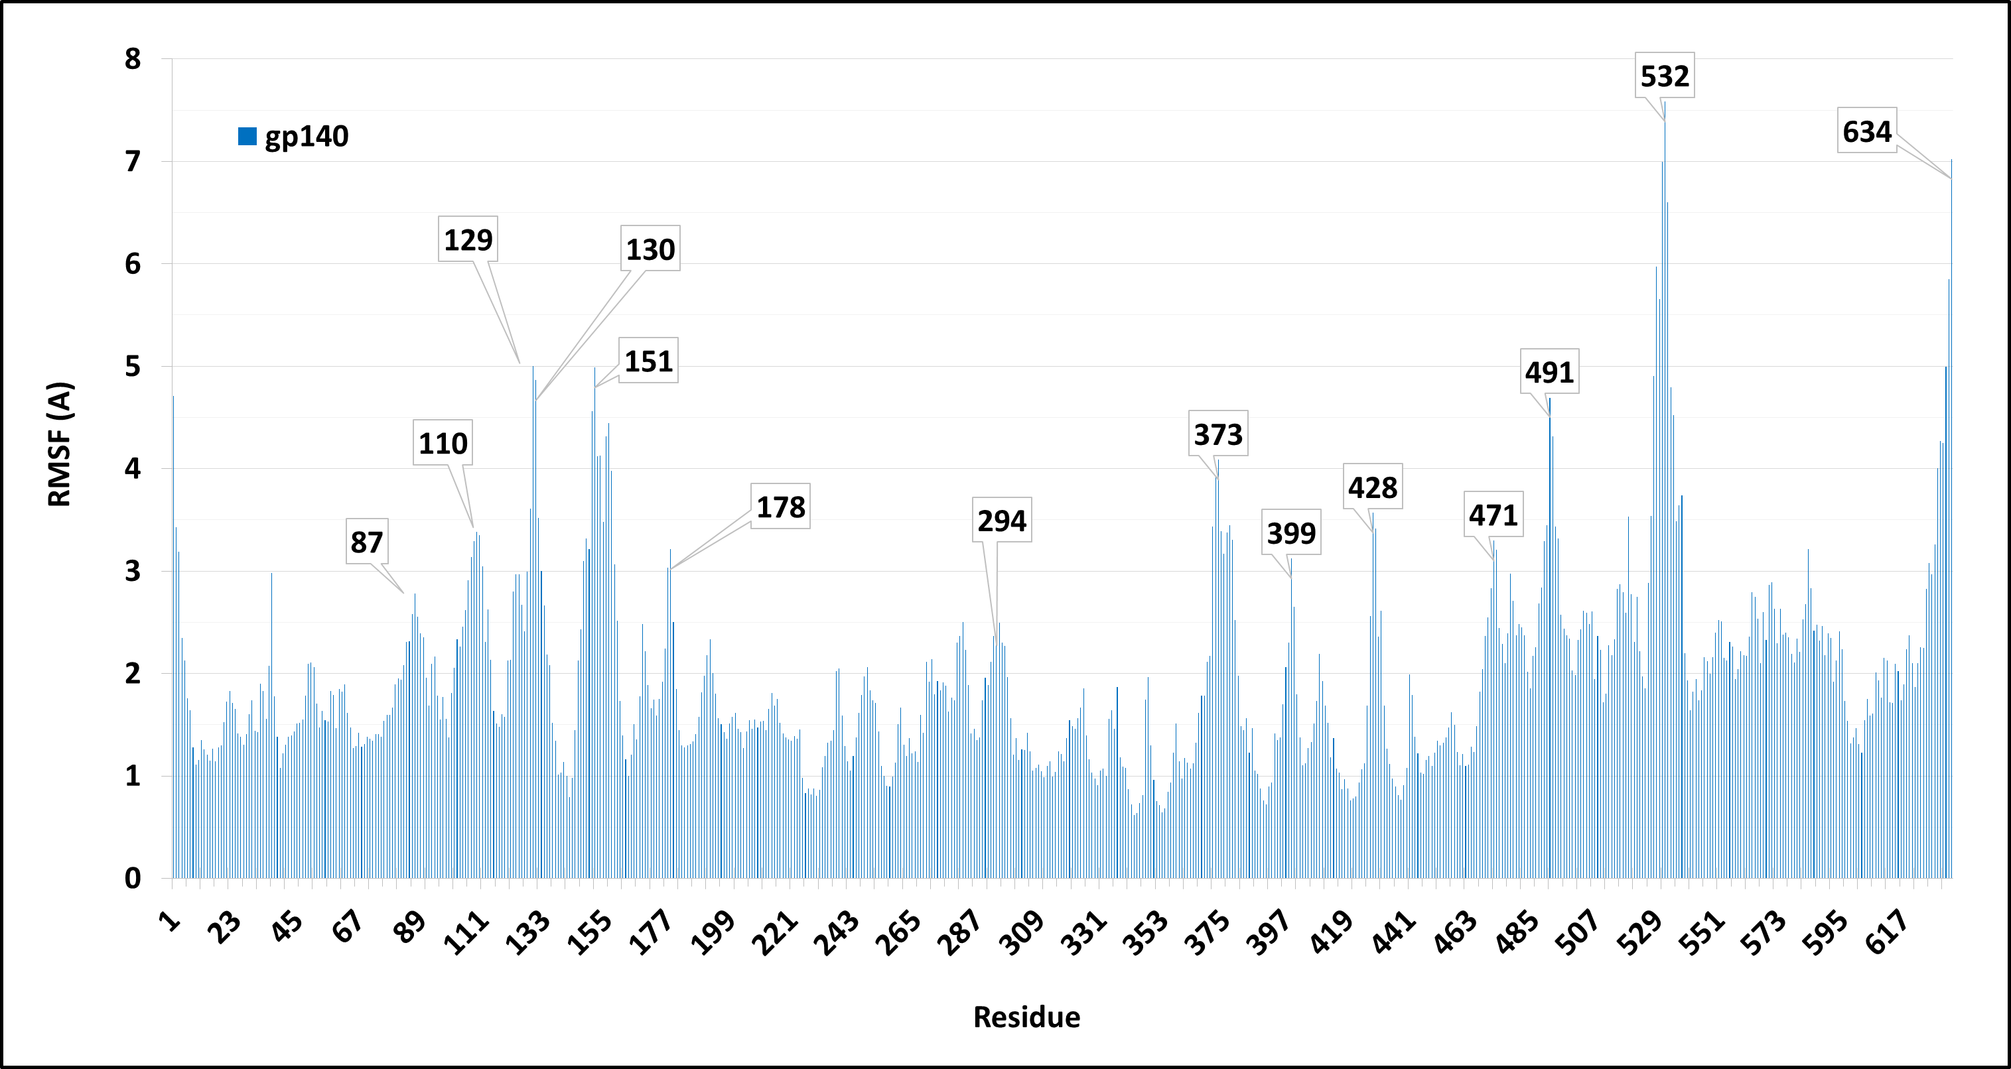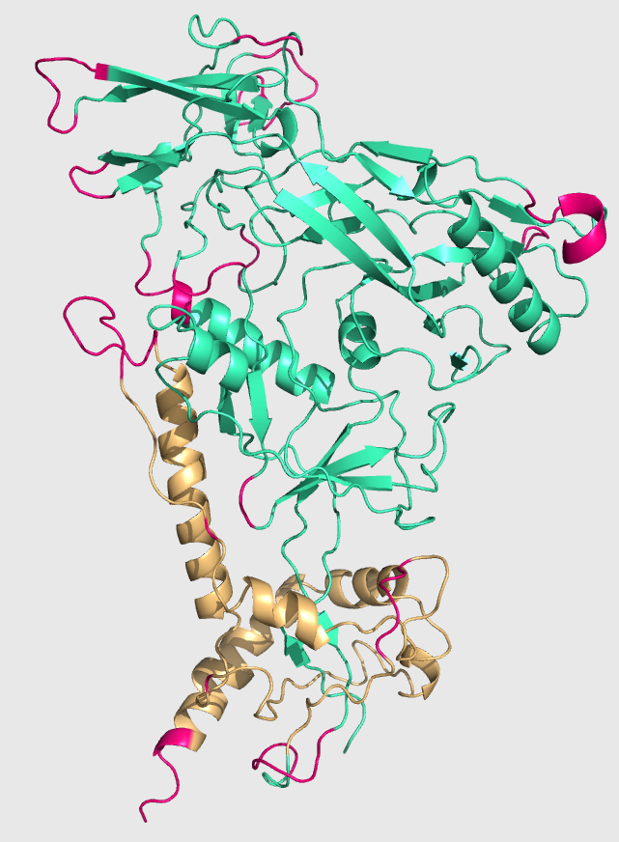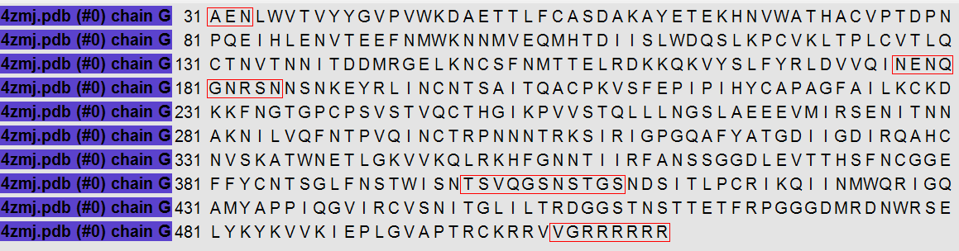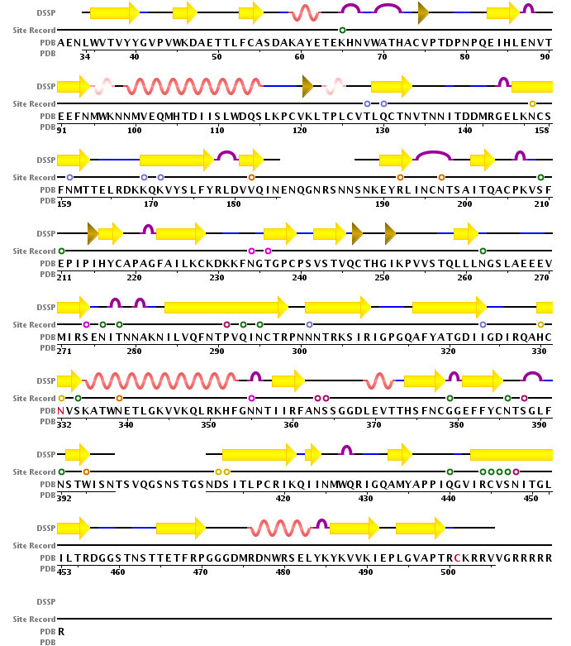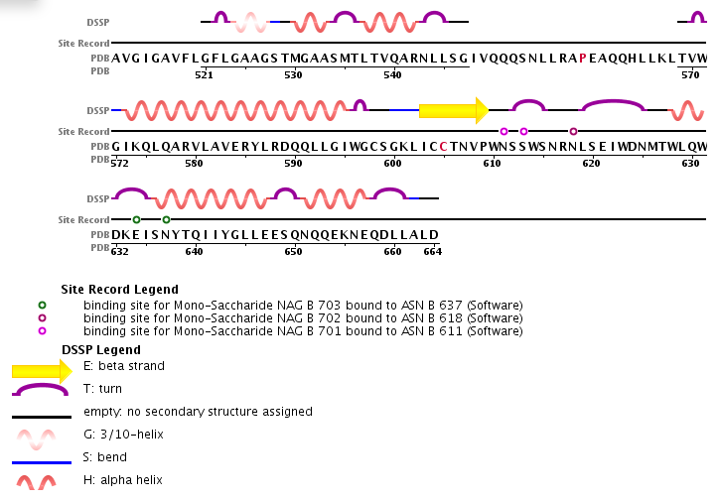

>P1;4zmj_trimer_restored_seq

AENLWVTVYYGVPVWKDAETTLFCASDAKAYETEKHNVWATHACVPTDPNPQEIHLENVT

EEFNMWKNNMVEQMHTDIISLWDQSLKPCVKLTPLCVTLQCTNVTNNITDDMRGELKNCS

FNMTTELRDKKQKVYSLFYRLDVVQINENQGNRSNNSNKEYRLINCNTSAITQACPKVSF

EPIPIHYCAPAGFAILKCKDKKFNGTGPCPSVSTVQCTHGIKPVVSTQLLLNGSLAEEEV

MIRSENITNNAKNILVQFNTPVQINCTRPNNNTRKSIRIGPGQAFYATGDIIGDIRQAHC

NVSKATWNETLGKVVKQLRKHFGNNTIIRFANSSGGDLEVTTHSFNCGGEFFYCNTSGLF

NSTWISNTSVQGSNSTGSNDSITLPCRIKQIINMWQRIGQAMYAPPIQGVIRCVSNITGL

ILTRDGGSTNSTTETFRPGGGDMRDNWRSELYKYKVVKIEPLGVAPTRCKRRVVGAVGIG

AVFLGFLGAAGSTMGAASMTLTVQARNLLSGIVQQQSNLLRAPEAQQHLLKLTVWGIKQL

QARVLAVERYLRDQQLLGIWGCSGKLICCTNVPWNSSWSNRNLSEIWDNMTWLQWDKEIS

NYTQIIYGLLEESQNQQEKNEQDLLALD*

>P1;4zmj_trimer.pdb

---LWVTVYYGVPVWKDAETTLFCASDAKAYETEKHNVWATHACVPTDPNPQEIHLENVT

EEFNMWKNNMVEQMHTDIISLWDQSLKPCVKLTPLCVTLQCTNVTNNITDDMRGELKNCS

FNMTTELRDKKQKVYSLFYRLDVVQI---------NSNKEYRLINCNTSAITQACPKVSF

EPIPIHYCAPAGFAILKCKDKKFNGTGPCPSVSTVQCTHGIKPVVSTQLLLNGSLAEEEV

MIRSENITNNAKNILVQFNTPVQINCTRPNNNTRKSIRIGPGQAFYATGDIIGDIRQAHC

NVSKATWNETLGKVVKQLRKHFGNNTIIRFANSSGGDLEVTTHSFNCGGEFFYCNTSGLF

NSTWISN-----------NDSITLPCRIKQIINMWQRIGQAMYAPPIQGVIRCVSNITGL

ILTRDGGSTNSTTETFRPGGGDMRDNWRSELYKYKVVKIEPLGVAPTRCKRRV-------

----GFLGAAGSTMGAASMTLTVQARNLLSG---------------------TVWGIKQL

QARVLAVERYLRDQQLLGIWGCSGKLICCTNVPWNSSWSNRNLSEIWDNMTWLQWDKEIS

NYTQIIYGLLEESQNQQEKNEQDLLALD

>BG505_full_sequence

structureX:pm.pdb:1 :A:1884 :F:::-1.00:-1.00

AENLWVTVYYGVPVWKDAETTLFCASDAKAYETEKHNVWATHACVPTDPNPQEIHLENVTEEFNMWKNNMVEQMH

TDIISLWDQSLKPCVKLTPLCVTLQCTNVTNNITDDMRGELKNCSFNMTTELRDKKQKVYSLFYRLDVVQINENQ

GNRSNNSNKEYRLINCNTSAITQACPKVSFEPIPIHYCAPAGFAILKCKDKKFNGTGPCPSVSTVQCTHGIKPVV

STQLLLNGSLAEEEVMIRSENITNNAKNILVQFNTPVQINCTRPNNNTRKSIRIGPGQAFYATGDIIGDIRQAHC

NVSKATWNETLGKVVKQLRKHFGNNTIIRFANSSGGDLEVTTHSFNCGGEFFYCNTSGLFNSTWISNTSVQGSNS

TGSNDSITLPCRIKQIINMWQRIGQAMYAPPIQGVIRCVSNITGLILTRDGGSTNSTTETFRPGGGDMRDNWRSE

LYKYKVVKIEPLGVAPTRCKRRVVG/AVGIGAVFLGFLGAAGSTMGAASMTLTVQARNLLSGIVQQQSNLLRAPE

AQQHLLKLTVWGIKQLQARVLAVERYLRDQQLLGIWGCSGKLICCTNVPWNSSWSNRNLSEIWDNMTWLQWDKEI

SNYTQIIYGLLEESQNQQEKNEQDLLALD/AENLWVTVYYGVPVWKDAETTLFCASDAKAYETEKHNVWATHACV

PTDPNPQEIHLENVTEEFNMWKNNMVEQMHTDIISLWDQSLKPCVKLTPLCVTLQCTNVTNNITDDMRGELKNCS

FNMTTELRDKKQKVYSLFYRLDVVQINENQGNRSNNSNKEYRLINCNTSAITQACPKVSFEPIPIHYCAPAGFAI

LKCKDKKFNGTGPCPSVSTVQCTHGIKPVVSTQLLLNGSLAEEEVMIRSENITNNAKNILVQFNTPVQINCTRPN

NNTRKSIRIGPGQAFYATGDIIGDIRQAHCNVSKATWNETLGKVVKQLRKHFGNNTIIRFANSSGGDLEVTTHSF

NCGGEFFYCNTSGLFNSTWISNTSVQGSNSTGSNDSITLPCRIKQIINMWQRIGQAMYAPPIQGVIRCVSNITGL

ILTRDGGSTNSTTETFRPGGGDMRDNWRSELYKYKVVKIEPLGVAPTRCKRRVVG/AVGIGAVFLGFLGAAGSTM

GAASMTLTVQARNLLSGIVQQQSNLLRAPEAQQHLLKLTVWGIKQLQARVLAVERYLRDQQLLGIWGCSGKLICC

TNVPWNSSWSNRNLSEIWDNMTWLQWDKEISNYTQIIYGLLEESQNQQEKNEQDLLALD/AENLWVTVYYGVPVW

KDAETTLFCASDAKAYETEKHNVWATHACVPTDPNPQEIHLENVTEEFNMWKNNMVEQMHTDIISLWDQSLKPCV

KLTPLCVTLQCTNVTNNITDDMRGELKNCSFNMTTELRDKKQKVYSLFYRLDVVQINENQGNRSNNSNKEYRLIN

CNTSAITQACPKVSFEPIPIHYCAPAGFAILKCKDKKFNGTGPCPSVSTVQCTHGIKPVVSTQLLLNGSLAEEEV

MIRSENITNNAKNILVQFNTPVQINCTRPNNNTRKSIRIGPGQAFYATGDIIGDIRQAHCNVSKATWNETLGKVV

KQLRKHFGNNTIIRFANSSGGDLEVTTHSFNCGGEFFYCNTSGLFNSTWISNTSVQGSNSTGSNDSITLPCRIKQ

IINMWQRIGQAMYAPPIQGVIRCVSNITGLILTRDGGSTNSTTETFRPGGGDMRDNWRSELYKYKVVKIEPLGVA

PTRCKRRVVG/AVGIGAVFLGFLGAAGSTMGAASMTLTVQARNLLSGIVQQQSNLLRAPEAQQHLLKLTVWGIKQ

LQARVLAVERYLRDQQLLGIWGCSGKLICCTNVPWNSSWSNRNLSEIWDNMTWLQWDKEISNYTQIIYGLLEESQ

NQQEKNEQDLLALD*

>4zmj_template

structureX:6chains1seq.pdb:1 :A:+1719:F:::-1.00:-1.00

---LWVTVYYGVPVWKDAETTLFCASDAKAYETEKHNVWATHACVPTDPNPQEIHLENVTEEFNMWKNNMVEQMH

TDIISLWDQSLKPCVKLTPLCVTLQCTNVTNNITDDMRGELKNCSFNMTTELRDKKQKVYSLFYRLDVVQIN---

------SNKEYRLINCNTSAITQACPKVSFEPIPIHYCAPAGFAILKCKDKKFNGTGPCPSVSTVQCTHGIKPVV

STQLLLNGSLAEEEVMIRSENITNNAKNILVQFNTPVQINCTRPNNNTRKSIRIGPGQAFYATDGIIGDIRQAHC

NVSKATWNETLGKVVKQLRKHFGNNTIIRFANSSGGDLEVTTHSFNCGGEFFYCNTSGLFNSTWISN--------

---NDSITLPCRIKQIINMWQRIGQAMYAPPIQGVIRCVSNITGLILTRDGGSTNSTTETFRPGGGDMRDNWRSE

LYKYKVVKIEPLGVAPTRCKRRV--/---------GFLGAAGSTMGAASMTLTVQARNLLSG-------------

--------TVWGIKQLQARVLAVERYLRDQQLLGIWGCSGKLICCTNVPWNSSWSNRNLSEIWDNMTWLQWDKEI

SNYTQIIYGLLEESQNQQEKNEQDLLALD/---LWVTVYYGVPVWKDAETTLFCASDAKAYETEKHNVWATHACV

PTDPNPQEIHLENVTEEFNMWKNNMVEQMHTDIISLWDQSLKPCVKLTPLCVTLQCTNVTNNITDDMRGELKNCS

FNMTTELRDKKQKVYSLFYRLDVVQIN---------SNKEYRLINCNTSAITQACPKVSFEPIPIHYCAPAGFAI

LKCKDKKFNGTGPCPSVSTVQCTHGIKPVVSTQLLLNGSLAEEEVMIRSENITNNAKNILVQFNTPVQINCTRPN

NNTRKSIRIGPGQAFYATDGIIGDIRQAHCNVSKATWNETLGKVVKQLRKHFGNNTIIRFANSSGGDLEVTTHSF

NCGGEFFYCNTSGLFNSTWISN-----------NDSITLPCRIKQIINMWQRIGQAMYAPPIQGVIRCVSNITGL

ILTRDGGSTNSTTETFRPGGGDMRDNWRSELYKYKVVKIEPLGVAPTRCKRRV--/---------GFLGAAGSTM

GAASMTLTVQARNLLSG---------------------TVWGIKQLQARVLAVERYLRDQQLLGIWGCSGKLICC

TNVPWNSSWSNRNLSEIWDNMTWLQWDKEISNYTQIIYGLLEESQNQQEKNEQDLLALD/---LWVTVYYGVPVW

KDAETTLFCASDAKAYETEKHNVWATHACVPTDPNPQEIHLENVTEEFNMWKNNMVEQMHTDIISLWDQSLKPCV

KLTPLCVTLQCTNVTNNITDDMRGELKNCSFNMTTELRDKKQKVYSLFYRLDVVQIN---------SNKEYRLIN

CNTSAITQACPKVSFEPIPIHYCAPAGFAILKCKDKKFNGTGPCPSVSTVQCTHGIKPVVSTQLLLNGSLAEEEV

MIRSENITNNAKNILVQFNTPVQINCTRPNNNTRKSIRIGPGQAFYATDGIIGDIRQAHCNVSKATWNETLGKVV

KQLRKHFGNNTIIRFANSSGGDLEVTTHSFNCGGEFFYCNTSGLFNSTWISN-----------NDSITLPCRIKQ

IINMWQRIGQAMYAPPIQGVIRCVSNITGLILTRDGGSTNSTTETFRPGGGDMRDNWRSELYKYKVVKIEPLGVA

PTRCKRRV--/---------GFLGAAGSTMGAASMTLTVQARNLLSG---------------------TVWGIKQ

LQARVLAVERYLRDQQLLGIWGCSGKLICCTNVPWNSSWSNRNLSEIWDNMTWLQWDKEISNYTQIIYGLLEESQ

NQQEKNEQDLLALD*

